Programming Fundamentals Lab Assignment #4

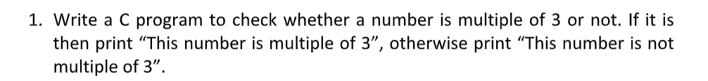

#include<stdio.h>

int main () {

int number, remainder;

printf("Please enter your number: ");

scanf("%d",&number);

remainder=number%3;

switch (remainder) {

case 0:

printf("This number is a multiple of 3");

break;

case 1:

printf("This number is not a multiple of 3");

break;

case 2:

printf("This number is not a multiple of 3");

break;

}

return 0;

}

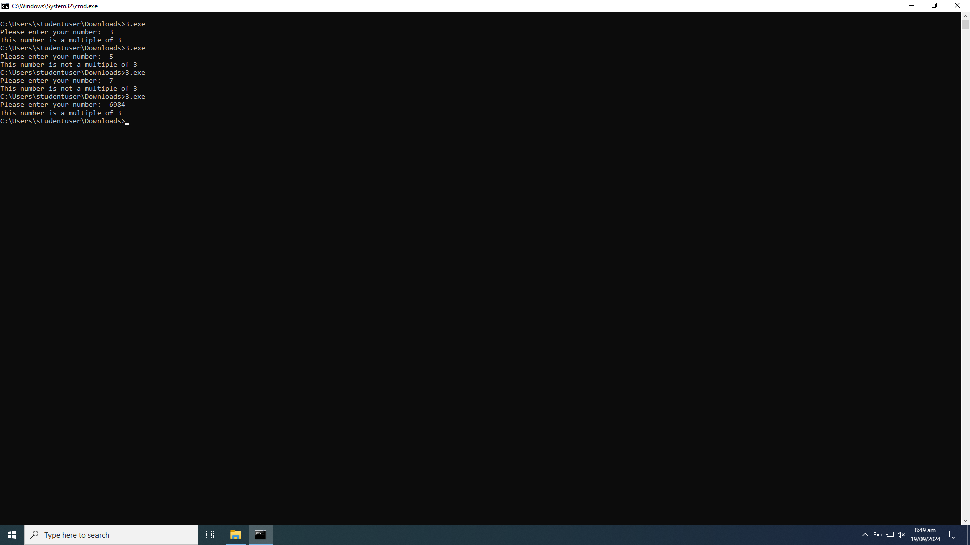



#include<stdio.h>

int main () {

float operand1, operand2;

char o;

printf("Please enter your first operand: ");

scanf("%f",&operand1);

printf("Please enter your second operand: ");

scanf("%f",&operand2);

printf("Please enter your operator. Choose from addition (+), subtraction (-), multiplication (\*), and division (/): ");

scanf(" %c",&o);

switch (o) {

case '+':

printf(" %f + %f = %.2f ", operand1, operand2, operand1+operand2);

break;

case '-':

printf(" %f - %f = %.2f ", operand1, operand2, operand1-operand2);

break;

case '\*':

printf(" %f \* %f = %.2f ", operand1, operand2, operand1\*operand2);

break;

case '/':

printf(" %f / %f = %.3f ", operand1, operand2, operand1/operand2);

break;

default:

printf("Invalid operator, please enter a valid operator");

break;

}

return 0;

}

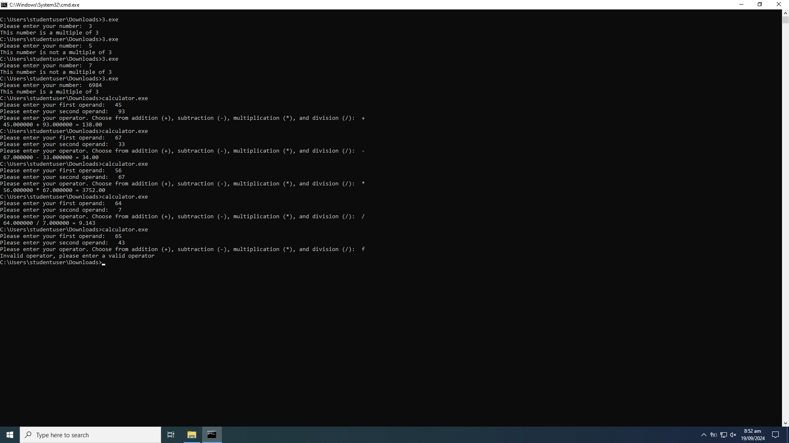

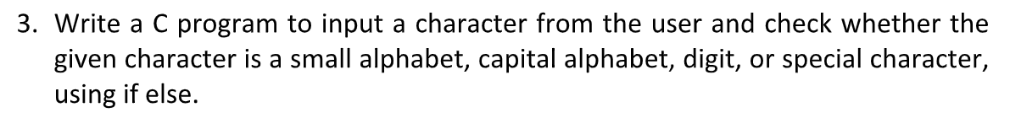

int main(){

char c;

printf("Please enter your character: ");

scanf(" %c",&c);

if (c>=33 && c<=47){

printf("Your character is a special character\n");

}else if (c>=58 && c<=64){

printf("Your character is a special character\n");

}else if (c>=48 && c<=57){

printf("Your character is a digit\n");

}else if (c>=65 && c<=90){

printf("Your character is a capital letter\n");

}else if (c>=97 && c<=122){

printf("Your character is a small letter\n");

}else if(c>=91 && c<=96) {

printf("Your character is a special character\n");

}else if(c>=123 && c<=126){

printf("Your character is a special character\n");

}else printf("invalid");

return 0;

}

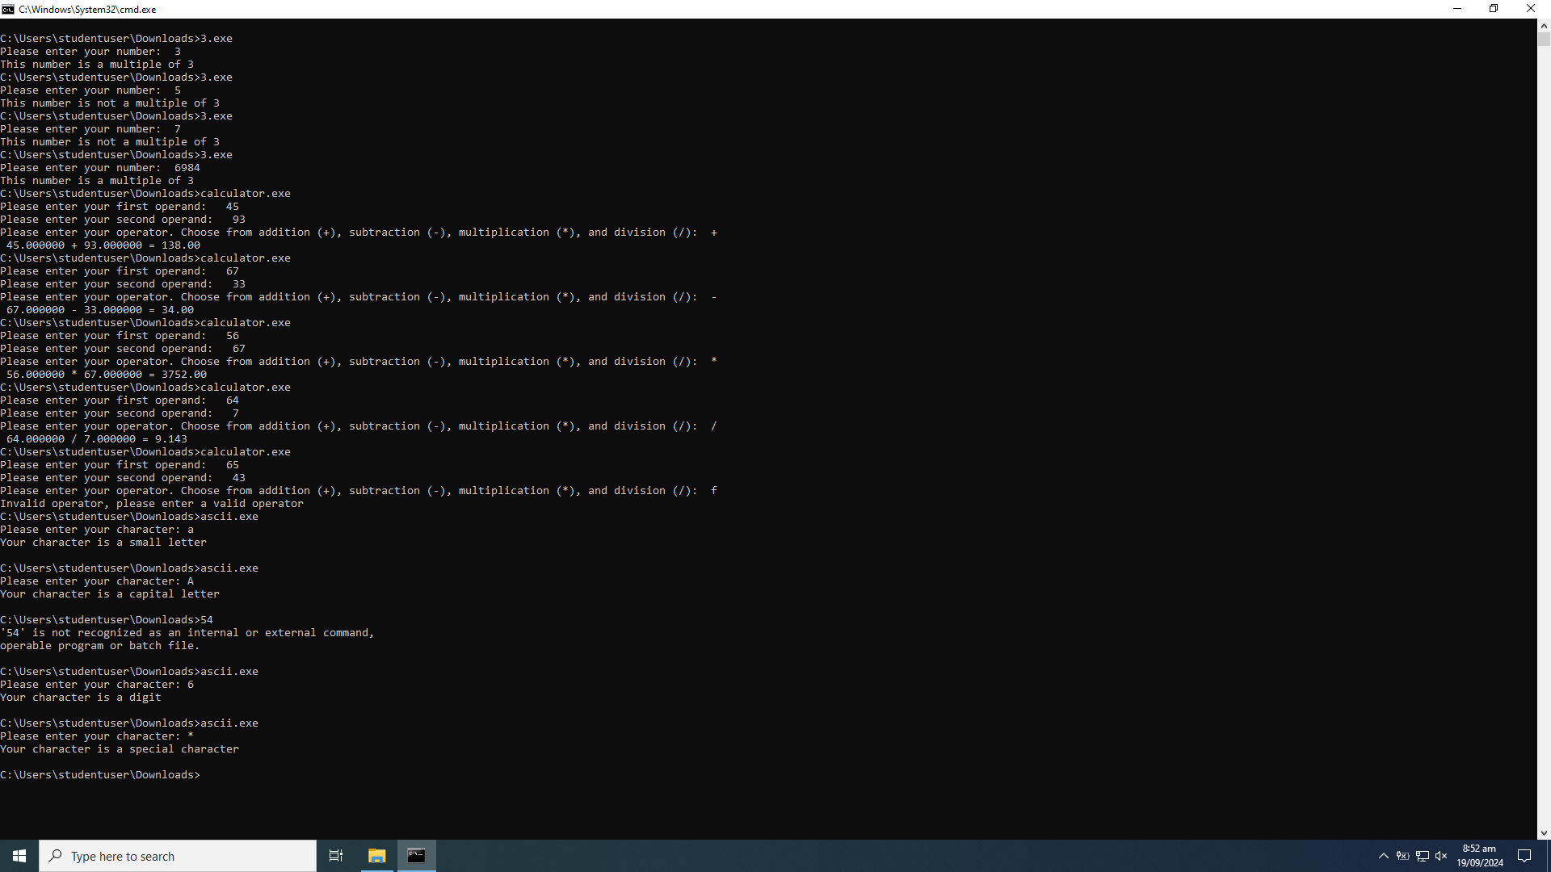



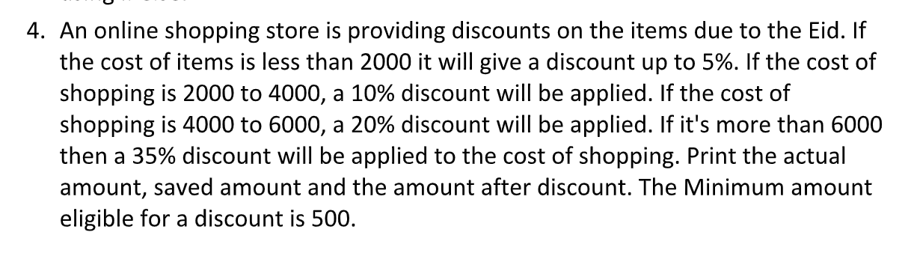

#include<stdio.h>

int main() {

float oldcost, saved, newcost;

printf("Please enter the amount you shopped for, in rupees: ");

scanf(" %f",&oldcost);

if (oldcost>=500 && oldcost<2000) {

saved=0.05\*oldcost;

newcost=oldcost-saved;

printf(" Your amount before discount was %.2f rupees.\n",oldcost);

printf(" You receive a 5 percent Eid discount and you saved %.2f rupees!\n Your new discounted amount is %.2f rupees!\n Happy Eid shopping! ",saved,newcost);

}else if (oldcost>=2000 && oldcost<4000) {

saved=0.1\*oldcost;

newcost=oldcost-saved;

printf(" Your amount before discount was %.2f rupees.\n",oldcost);

printf(" You receive a 10 percent Eid discount and you saved %.2f rupees! \nYour new discounted amount is %.2f rupees!\n Happy Eid shopping! ",saved,newcost);

}else if (oldcost>=4000 && oldcost<=6000) {

saved=0.2\*oldcost;

newcost=oldcost-saved;

printf(" Your amount before discount was %.2f rupees.\n",oldcost);

printf(" You receive a 20 percent Eid discount and you saved %.2f rupees!\n Your new discounted amount is %.2f rupees!\n Happy Eid shopping! ",saved,newcost);

}else if (oldcost>6000) {

saved=0.35\*oldcost;

newcost=oldcost-saved;

printf(" Your amount before discount was %.2f rupees.\n",oldcost);

printf(" You receive a 35 percent Eid discount and you saved %.2f rupees!\n Your new discounted amount is %.2f rupees!\n Happy Eid shopping! ",saved,newcost);

}else {

printf(" Dear customer, you need to shop products worth of at least 500 RS to avail the Eid sale discount. \nYour total amount is %.2f. ",oldcost);

}

return 0;

}

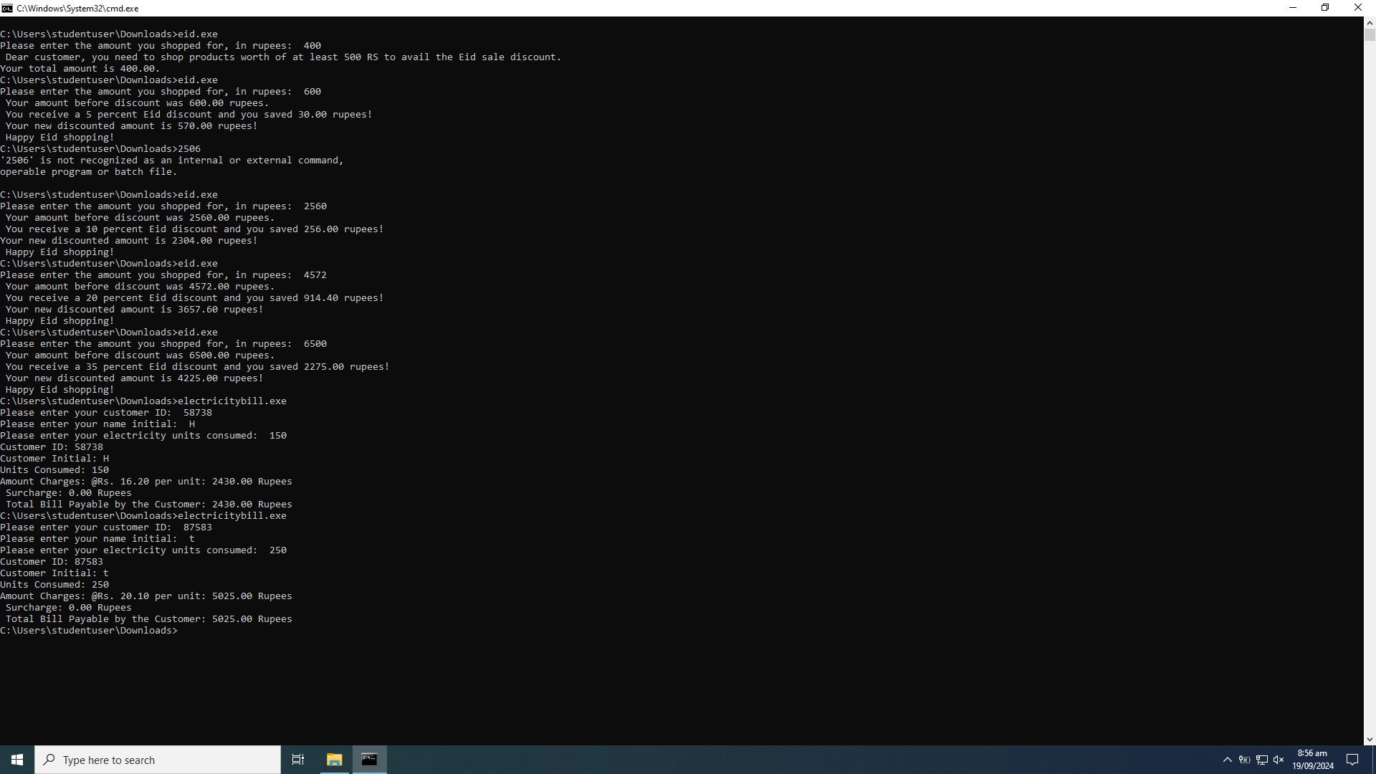

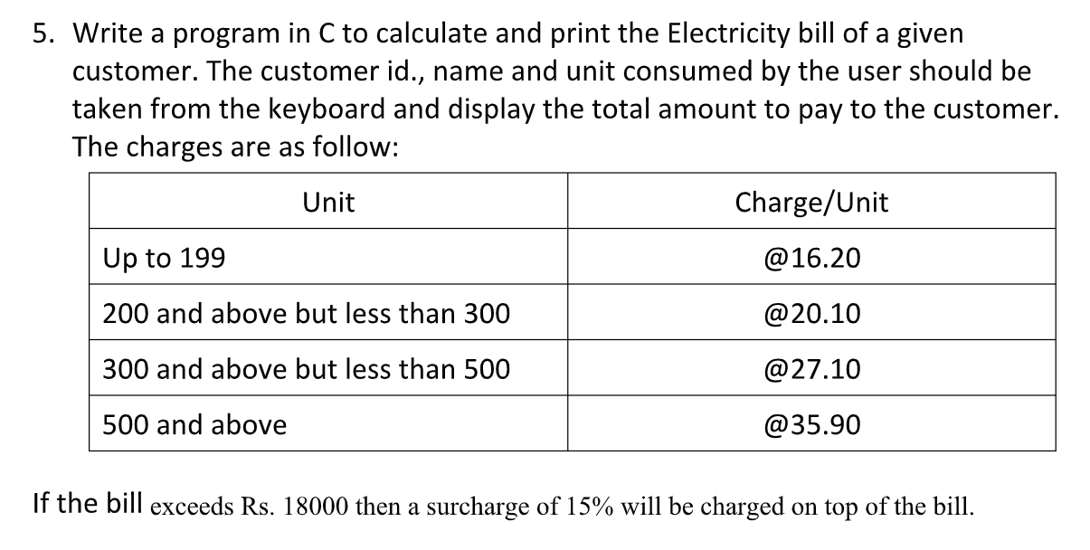

#include <stdio.h>

int main() {

int customerID, unitsconsumed;

float amount, unitcost, bill, surcharge;

char N;

printf("Please enter your customer ID: ");

scanf("%d",&customerID);

printf("Please enter your name initial: ");

scanf(" %c",&N);

printf("Please enter your electricity units consumed: ");

scanf("%d",&unitsconsumed);

if(unitsconsumed<0){

printf("Invalid\n");

}else if(unitsconsumed>=0 && unitsconsumed<=199){

amount=16.20\*unitsconsumed;

bill=amount;

unitcost=16.20;

}else if (unitsconsumed>=200 && unitsconsumed<300){

amount=20.10\*unitsconsumed;

bill=amount;

unitcost=20.10;

}else if (unitsconsumed>=300 && unitsconsumed<500){

amount=27.10\*unitsconsumed;

bill=amount;

unitcost=27.10;

}else {amount=35.90\*unitsconsumed;

unitcost=35.90;

if (amount>18000)

bill= 1.15\*amount;

else bill= amount;}

surcharge=bill-amount;

printf("Customer ID: %d \nCustomer Initial: %c \nUnits Consumed: %d \nAmount Charges: @Rs. %.2f per unit: %.2f Rupees \n Surcharge: %.2f Rupees\n Total Bill Payable by the Customer: %.2f Rupees ",customerID,N,unitsconsumed,unitcost,amount,surcharge,bill);

return 0;

}

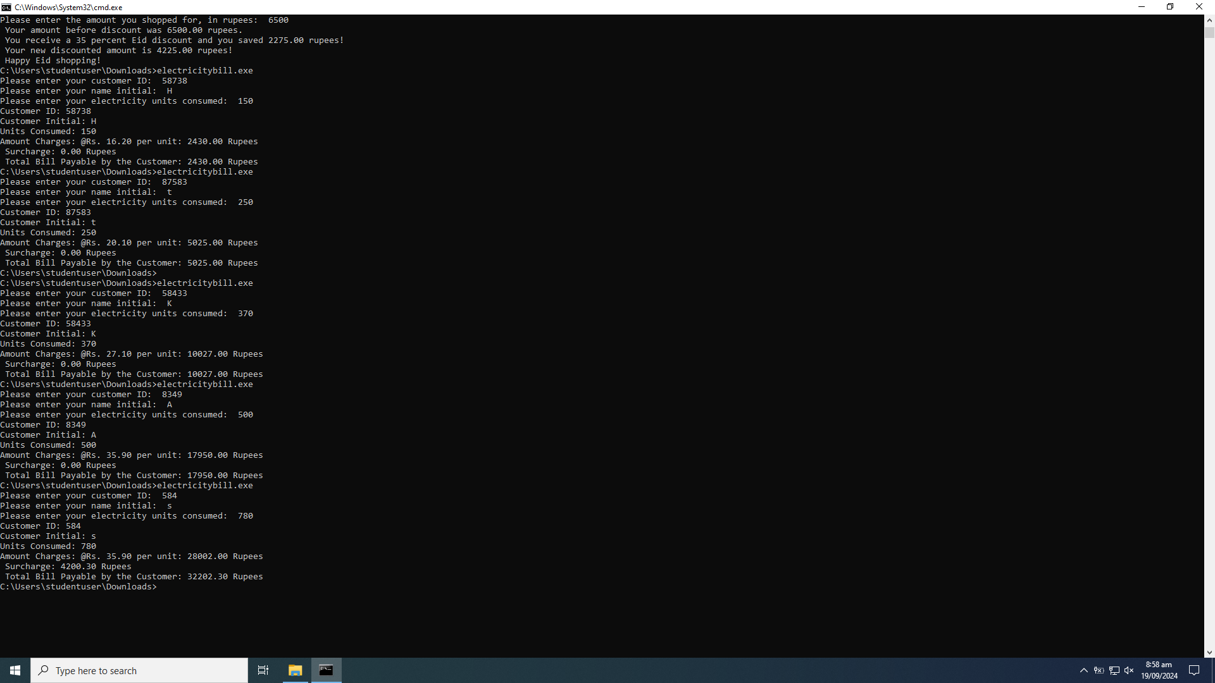

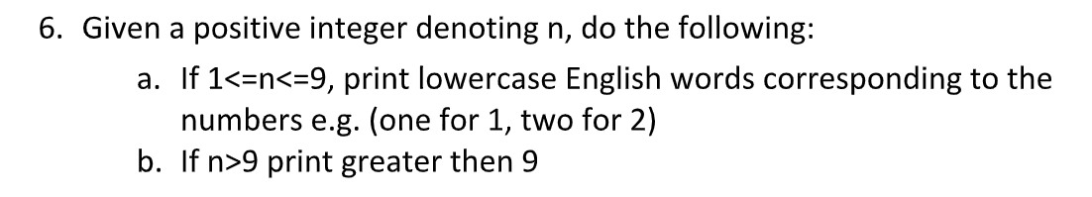

#include <stdio.h>

int main() {

int number;

printf("Please enter your number: ");

scanf("%d",&number);

if (number<1){

printf("Invalid, enter an integer greater than 0");

}else if (number>9){

printf("This number is greater than nine");

}else switch (number){

case 1:

printf("This is number one");

break;

case 2:

printf("This is number two");

break;

case 3:

printf("This is number three");

break;

case 4:

printf("This is number four");

break;

case 5:

printf("This is number five");

break;

case 6:

printf("This is number six");

break;

case 7:

printf("This is number seven");

break;

case 8:

printf("This is number eight");

break;

case 9:

printf("This is number nine");

break;

}

return 0;

}

